NVTool User Guide

Owner：UNISOC
Version： V1.0
Date：2019/6/14

Contents
1 Overview 1
1.1 NVTool Introduction 1
1.1.1 Toolkit 1
1.1.2 Tool Introduction 1
1.2 Environment 1
1.2.1 Hardware environment 1
1.2.2 Software environment 1
2 Quick Start 2
2.1 Quick Start 2
3 Operation Guide 5
3.1 Toolbar 5
3.2 Menu 5
3.2.1 File menu 5
3.2.2 Facility Menu 8
3.2.3 Help Menu 10
4 Command Line Application 12
4.1 Overview 12
4.2 Operation Guide 12
4.2.1 Parameter formate 12
4.2.2 Parameter explain 13

Photo Contents
Photo 2.1 Main UI 2
Photo 2.2 Loaded NV Project 3
Photo 2.3 Editor NV Parameter 3
Photo 2.4 Generated NV Image file 4
Phote 3.1 Toolbar 5
Photo 3.2 File Menu 6
Photo 3.3 Port Settings 7
Photo 3.4 Calibration devices 7
Photo 3.5 Facility Menu 8
Poto 3.6 NV file format 9
Photo 3.7 Import NV File 9
Photo 3.8 DeltaNV Bin Settings 10
Photo 3.9 Help Menu 10
Photo 3.10 Upgrade 11
Photo 3.11 No new version 11
Photo 4.1 Command line parameter 13

Table Contents
table 1.1 Toolkit 1
table 1.2 NVool function 1
table 1.3 Hardware Configuration 1
table 1.4 Software Configuration 1
table 3.1 Toolbar 5
table 3.2 File Menu 6
table 3.3 Port Setting 7
table 3.4 Facility Menu 8
table 3.5 Delta NV Bin Settings 10
table 3.6 Help Menu 10

Overview

NVTool Introduction

Toolkit
NVTool is unisoc NV2.X project’s toolkit，It include below three applications：

Name | Descriptions
NVTool.exe | GUI Tool
CmdNV.exe | Window command line application
LinuxCmdNV | Linux command line application
table 1.1 Toolkit

Tool Introduction
NVTool is unisoc NV2.X project’s GUI tool，support below functions：

Function | Descriptions
Edit NV | Edit and modify nv data
Generate NV Image | Generate NV image file
Read nv data from phone | Read nv data from phone via usb or uart
Wrtie nv data to phone | Wrtie nv data to phone via usb or uart
table 1.2 NVool function

Environment

Hardware environment
Hardware | basic requirements
PC Memery | 4G and above
PC hard disk | 4G and above free space
PC USB Port | At least one USB port
Cable | Uart or usb cable
table 1.3 Hardware Configuration

Software environment
Software | basic requirements
OS | Windows 7 and above
USB driver | 2.0.0.131 and above
table 1.4 Software Configuration

Quick Start
This chapter describes how to use NVTool to do NV by quick steps

Quick Start

Click NVTool.exe to launch, GUI is as below（"R1.19.2501" is tool's demo version,The version number will be continuously upgraded, which is based on the actual tool interface.）
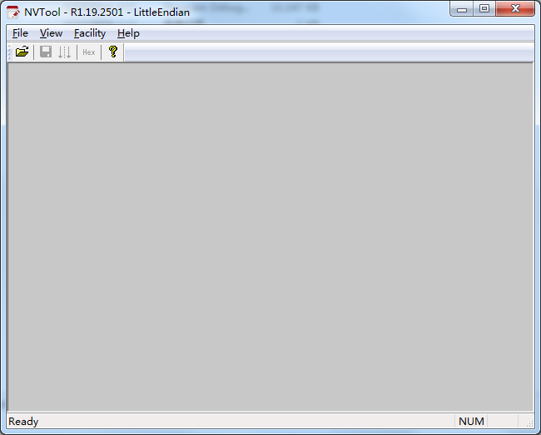
Photo 2.1 Main UI

Step1：Open NV project file
You can open the nv project in the following ways：
- Select［File\Open Project］menu
- Ctrl+O Shortcut
- Click icon on toolbar
- ［File］There is a list of recently opened projects under the menu item，Directly select one of the recent NV projects.
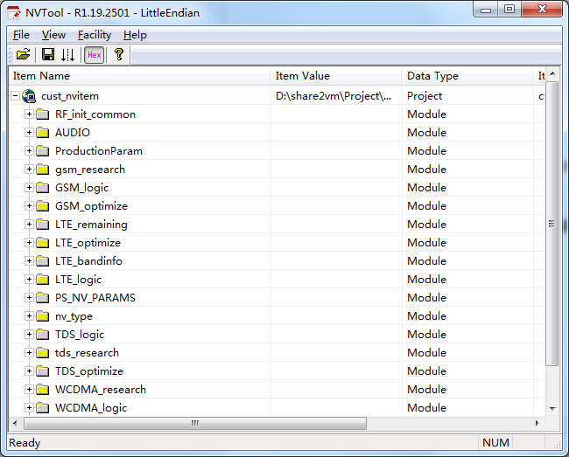
Photo 2.2 Loaded NV Project

Step2：Edit NV parameter
Double-click the value you want to modify or select the value you want to modify. Press the
Enter key. An edit box will appear and you can enter the new value.
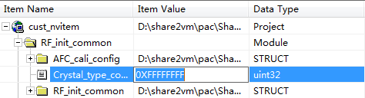
Photo 2.3 Editor NV Parameter

Step3：Generate NV Image
Select［File\Save Image］menu to generate a new nv image file，The new NV image
file is saved in the same directory of the nv project.

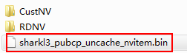
Photo 2.4 Generated NV Image file

Step4：Save NV project
Select［File\Save Project］menu or Click icon on the toolbar, then can generate
nv image file and save nv project.

Operation Guide

Toolbar
Phote 3.1 Toolbar

Icon | Descriptions
 | Open project
 | Save project
Save nv parameter to phone（it is same as [File \Save To Phone
（Normal mode）] menu
 | Decimal or hexadecimal display nv parameter switch,defult is hexadecimal
 | Help
table 3.1 Toolbar

Menu

File menu
［File］menus as below:
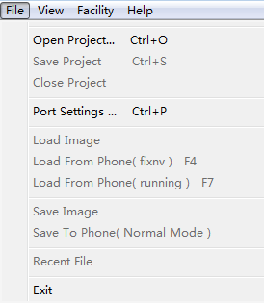
Photo 3.2 File Menu

Menu | Descriptions
Open Project | Open nv project or nv xml file
Save Project | Save nv project and save nv image file
Close Project | Close nv project
Port Settings | Port setting, using for read nv from phone or write nv to phone
Load Image | Load nv image to nv project
Load From Phone ( fixnv ) | Load fixnv from phone, phone, The device needs to enter calibration mode, port is u2s diag device
Load From Phone ( running ) | Load running nv from phone, default is disable, If you need to use this function, you can modify below config in NVTool.ini file  [GUI]  EnableLoadRunningNvMenu = 1
Save Image | Save nv image file
Save to Phone (Normal Mode) | Save nv items to phone
Exit | Exit application
table 3.2 File Menu

Load Image
This function can parse the NV image file and import the NV parameters of the selected NV
image into the open NV project.

Port Settings
［File\Port Settings］menu and Ctrl+P shortcut can open port settings windows, this port
setting just for read nv parameters from phone or write nv parameters to phone. Please select
this function menu before connected the device.
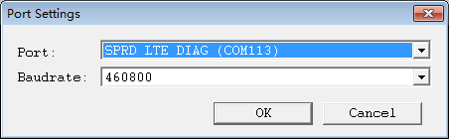
Photo 3.3 Port Settings

Item | Descriptions
Port | Uart or usb port
Baudrate | Baudrate, just for uart connect
table 3.3 Port Setting

Load From Phone ( fixnv )
After loading the NV project, you can use this menu function to read the device's fixnv in
calibration mode. Additional tools are required to bring the device into calibration mode.
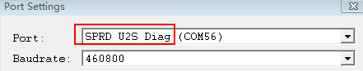
Photo 3.4 Calibration devices

Load From Phone ( runningnv )
This feature is turned off by default，This feature can be turned on by modifying the configuration. After loading the NV project, you can use this menu function to read the runningnv of the device in the boot/calibration mode. If you read in the boot mode, you need to ensure that the Modem to PC function is enabled in the engineering mode of the device.

Save To Phone (Normal Mode)
After loading the NV project, you can use this menu function to write nv parameters to the runningnv of the device in the boot/calibration mode.

Facility Menu
［Facility］Menu as below:
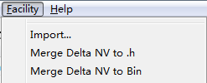
Photo 3.5 Facility Menu

Item | Descriptions
Import | Import nv file
Merge Delta NV to .h | Generate nv_config.h file under the nv project directory
Merge Delta NV to Bin | Generate delta_nv.bin file under the delta nv directory
table 3.4 Facility Menu

Import
This feature supports importing NV file content into a loaded NV project，The imported
difference item will displayed by red color. NV file is generally exported from NVTool,
Audiotest, NVAide, etc. or manually generated .nv files. The left side of the equal sign is the
NV path, The right side of the equal sign is the NV value. Format is as below:
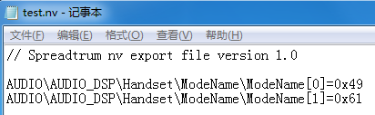
Poto 3.6 NV file format

Demo after import nv file:
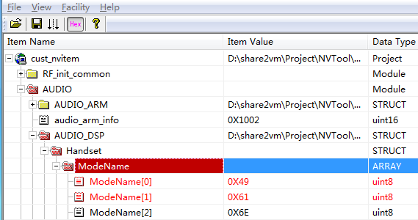
Photo 3.7 Import NV File
Explain：
If the same nv item but difference value exists in the imported delta nv file,
only the last one is imported into the nv project。
e.g. If the following two differential nv appear, the value that is finally imported into the project
is actually 0x62
AUDIO\AUDIO_DSP\Handset\ModeName\ModeName[1]=0x61
AUDIO\AUDIO_DSP\Handset\ModeName\ModeName[1]=0x62

Merge Delta NV to Bin
This function is used to generate delta nv image file.
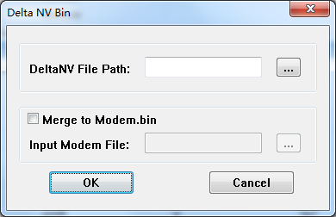
Photo 3.8 DeltaNV Bin Settings

Item | Descriptions
Delta NV File Path | The directory of delta nv file（required）
Merge to Modem.bin | - If not selected, the delta_nv.bin file will be generated in the selected DeltaNV file path  - If selected，must select one modem file at the same time，Then will merge the generated delta_nv.bin file into the input modem file.
Input Modem File | Input modem file
OK | Click it and will generate file
table 3.5 Delta NV Bin Settings

Help Menu
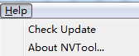
Photo 3.9 Help Menu

Item | Descriptions
Check Update | Check update NVtool
About NVTool | About NVTool infomation
table 3.6 Help Menu

Check Update

Checking the version function requires the PC to access the network，This function can manually check whether
the NVTool has an updated version, if there is an updated version, will show below upgrade UI, User can click
Upgrade Now button to upgrade NVTool. If user do not select “Do not prompt new version any more”
option, then The upgrade will also be automatically checked when launched the NVTool.
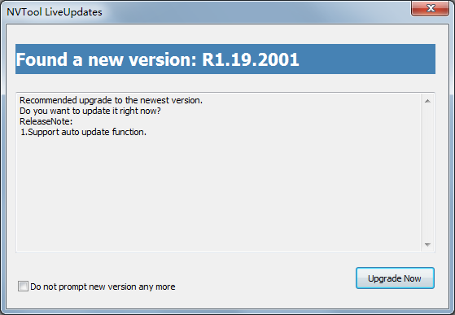
Photo 3.10 Upgrade

If not new version NVTool, will show below information.
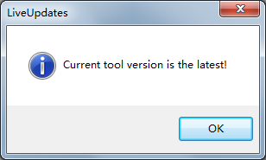
Photo 3.11 No new version

Command Line Application

Overview
CmdNV.exe and LinuxCmdNV tool is Windows and Linux command line application，The two sets of command line compilation tools have the same function and usage. This article only uses the CmdNV application as an example，The command line compilation tool supports the following features：
- Build xml and generate nv bin and header file
- Generate delta nv functions
- Import NV file and Generate nv image file

Operation Guide

Parameter formate
Import –h or-help parameter, can read command line application’s help.
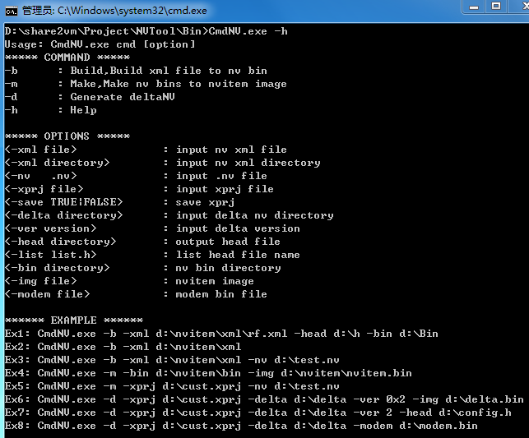
Photo 4.1 Command line parameter

Parameter explain

Build xml file
Compile the generated header file and bin file to the specified directory，This function is only
used when compiling the modem module. Customers generally do not need this function.
e.g. CmdNV.exe -b -xml d:\nvitem\xml\rf.xml -head d:\h -bin d:\Bin

Build nv project and generate NV Image file
Ex1: build nv project and generate nv image file
CmdNV.exe -m -xprj d:\nvitem\RDNV\rd_nvitem.xprj
Ex2: import nv file and generate nv image file, it will import nv parameter to the nv project.
CmdNV.exe -m -xprj d:\nvitem\RDNV\rd_nvitem.xprj -nv d:\test.nv
Ex3: Import nv directory and generate nv image file.

CmdNV.exe -m -xprj d:\nvitem\RDNV\rd_nvitem.xprj -nv d:\testnv\

Build delta nv file
Ex1: Build and generate delta bin file
CmdNV.exe -d -xprj d:\nvitem\RDNV\rd_nvitem.xprj -delta d:\delta -ver 0x2 -img d:\delta.bin
-delta : input delta nv directory，-img : output delta bin file，-ver : Need to enter decimal or
hexadecimal content parameters starting with 0x. default not setting.
Ex2: Build and generate delta header file
CmdNV.exe -d -xprj d:\nvitem\RDNV\rd_nvitem.xprj -delta d:\delta -ver 2 -head d:\config.h
-delta : input delta nv directory，-head : output delta head file，-ver : Need to enter decimal
or hexadecimal content parameters starting with 0x. default not setting.

Ex3: Generate delta bin file and merge to modem bin file
CmdNV.exe -d -xprj d:\nvitem\RDNV\rd_nvitem.xprj -delta d:\delta -modem d:\modem.bin
-delta : input delta nv directory，-modem : input /output modem file

Revision history
Version | Date | Author | Description
V1.0 | 2019-06-14 | UNISOC | First version.

Confidential and Proprietary
All data and information contained in or disclosed by this document is confidential and proprietary information of UNISOC and all rights therein are expressly reserved. This document is provided for reference purpose, no license (express or implied, by estoppel or otherwise) to any intellectual property rights is granted by this document, and no express and implied warranties, including but without limitation, the implied warranties of fitness for any particular purpose, and non-infringement, as well as any performance. By accepting this material, the recipient agrees that the material and the information contained therein is to be held in confidence and in trust and will not be used, copied, reproduced in whole or in part, nor its contents revealed in any manner to others without the express written permission of UNISOC. UNISOC may make any changes at any time without prior notice. Although every reasonable effort is made to present current and accurate information, UNISOC makes no guarantees of any kind with respect to the matters addressed in this document. In no event shall UNISOC be responsible or liable, directly or indirectly, for any damage or loss caused or alleged to be caused by or in connection with the use of or reliance on any such content.

